A
Project Report On

Cryptocurrency Price Tracker
Submitted to
G H Raisoni Skill Tech University,
Nagpur

In partial fulfilment for the requirement of the Degree of Master of Computer Application
(MCA I Year, Semester II)

Submitted by
NANDINI SARODE POOJA DHAPODKAR
MCA I Year, Semester II Guided by

Prof. Ayesha Sheikh
Asst.Professor,GHRSTU,NAGPUR


G.H Raisoni Skill Tech University, Nagpur Department of Computer Application
2024-25

G. H. Raisoni Skill Tech University, Nagpur Department of Computer Application
2024-25


CERTIFICATE

This is to certify that the project titled “Cryptocurrency Price Tracker” has been submitted by Nandini Sarode & Pooja Dhapodkar. in partial fulfilment for the requirement of the Degree of Master of Computer Application MCA I Year, Semester
II. This is an original work carried out by us under guidance of Prof. Ayesha sheikh

DEAN,  GHRSTU, Nagpur | Asst. Professor,  GHRSTU, Nagpur

Date –
Place- Nagpur

DECLARATION

I hereby declare that the work presented in this project entitled “Cryptocurrency Price Tracker” was carried out by us under the supervision of Prof. Ayesha Sheikh. This work or any part of this work is based on original work and has not been submitted by anybody to any University / Institution for award of any diploma or degree.

Place:

Date:

Name of Student

Nandini Sarode Pooja Dhapodkar

Index

Chapter  Number | Title | Page  Number
1. | Introduction / Objectives | 2
2. | Preliminary System Analysis  - Identification of Need  - Preliminary Investigation  - Feasibility Study  - Need for New System  - Flaws in Present System | 5
3. | Project Statement | 11
4. | Software Requirement Specifications | 13
5. | Detailed System Analysis  - Data Flow Diagram  - Numbers of Modules and Process Logic  - Data Structure and Tables  - System Chart or Structure Chart  - Entity Relationship Diagram | 16
6. | System Design  - Form Design  - Input Screens  - Output Screen | 20
7. | Testing and Validation Checks. | 27
8. | Implementation, Evaluation and Maintenance | 30
9. | Reports and Discussions | 33
10. | Future Scopes | 36
11. | Bibliography | 38

CHAPTER NO.1 INTRODUCTION

- Introduction
In recent years, cryptocurrencies have emerged as a significant component of the global financial ecosystem, offering decentralized, transparent, and borderless alternatives to traditional monetary systems. However, the cryptocurrency market is notoriously volatile, with prices fluctuating rapidly due to various factors such as market sentiment, regulatory developments, and technological advancements. This high degree of volatility necessitates accurate, real-time price tracking tools for investors, traders, and enthusiasts to make well- informed decisions.
To address this need, the Cryptocurrency Price Tracker has been developed as a comprehensive web-based application that provides live price updates, interactive trend analysis, and data visualization for a wide range of cryptocurrencies. Designed with both novice and experienced users in mind, the platform prioritizes usability, responsiveness, and performance.
The system integrates multiple technologies to deliver a seamless user experience. The backend, powered by Python's Flask framework, fetches real-time cryptocurrency prices from trusted APIs such as CoinMarketCap. It works alongside a PHP-based structure to manage requests and user interactions. User preferences and application data are securely managed using SQLite3, ensuring lightweight yet reliable data storage. The frontend is built using Tailwind CSS to ensure responsive design across devices, while Lightweight Charts are employed to present dynamic and interactive graphical representations of cryptocurrency trends.
Overall, this project aims to bridge the gap between data complexity and user accessibility in the cryptocurrency domain, equipping users with timely and actionable insights.

Objective
The primary goal of the Cryptocurrency Price Tracker is to provide a reliable and efficient platform for monitoring the real-time behavior of digital currencies. The key objectives are as follows:
- Real-Time Price Tracking: Integrate trusted sources such as the CoinMarketCap API to fetch and display live cryptocurrency data.
- User-Friendly Interface: Design an intuitive and responsive frontend using Tailwind CSS to enhance usability and accessibility for all user types.
- Interactive Data Visualization: Implement Lightweight Charts to provide clear and interactive trend analysis of cryptocurrency prices over time.
- Comprehensive Coverage: Support multiple cryptocurrencies and exchanges, offering users a broad overview of the market.
- Performance & Scalability: Use Flask and SQLite3 to ensure fast response times and the ability to scale as user demand increases.
Security & Data Management: Provide secure user authentication and ensure the confidentiality of stored data through encryption and best practices.

CHAPTER NO.2
Preliminary System Analysis

- Preliminary System Analysis

  - Identification of Need
The increasing popularity and adoption of cryptocurrencies have transformed the global financial landscape. However, due to their inherently volatile nature, investors and traders require precise and real-time market data to make informed decisions. Traditional platforms often fall short in terms of responsiveness, clarity of data presentation, or accessibility for new users. Many existing tools are either too complex for beginners or lack the depth and accuracy that experienced investors demand.
Additionally, users require a centralized and user-friendly platform that offers both live data and trend analysis in a visually accessible format. The need is not just for raw numerical data but for comprehensive insights presented through clear visualizations, enabling users to understand market movements and predict future trends. In the absence of such a platform, users are forced to toggle between multiple websites, manually compile information, and often experience delayed data updates.
Given these challenges, there is a clear and growing need for a dedicated cryptocurrency price tracking system that is reliable, fast, and simple to use. This system should integrate real-time price data from multiple sources, offer intuitive charts, support various cryptocurrencies, and function well across all modern devices and browsers. The solution should also focus on security, scalability, and user customization features. Identifying this need lays the foundation for the development of the Cryptocurrency Price Tracker.

  - Preliminary Investigation
Before initiating full-scale development, a preliminary investigation was conducted to assess existing solutions and understand user expectations. Several cryptocurrency tracking platforms such as CoinMarketCap, CoinGecko, and Binance were analyzed for functionality, user interface design, and real-time capabilities. While these platforms offer vast data, they often overwhelm users with excessive information or limit customization options, making them less ideal for quick reference or personalized tracking.
In parallel, surveys and informal interviews were conducted with potential users, including beginner investors, day traders, and crypto enthusiasts. These interactions revealed common pain points such as slow data updates, cluttered interfaces, limited charting tools, and lack of platform responsiveness on mobile devices. Users also expressed the need for secure and private storage of preferences without the burden of account creation or lengthy setups.
Furthermore, technical evaluation of existing open-source tools showed that while some projects are community-driven, they lack regular updates or real-time integration with reputable APIs. Most are not optimized for performance or modern UI/UX expectations.
This investigation confirmed the feasibility and necessity of a new system—one that combines the simplicity of use, real-time functionality, secure backend, and visual clarity. It highlighted specific features that users expect and emphasized the importance of integrating modern development frameworks and APIs. Based on this preliminary investigation, the development of the Cryptocurrency Price Tracker was deemed justified and timely.

  - Feasibility Study
A feasibility study was conducted to evaluate whether the proposed Cryptocurrency Price Tracker system could be successfully developed and deployed with available resources and technology. The study considered several aspects: technical, economic, operational, legal, and schedule feasibility.
Technical Feasibility: The system utilizes proven technologies such as Python (Flask) for backend processing, PHP for request handling, SQLite3 for lightweight database management, and Tailwind CSS and JavaScript for frontend design. Integration with the CoinMarketCap API ensures reliable data sourcing. All chosen technologies are open-source and widely supported, making the technical implementation highly feasible.
Economic Feasibility: As most technologies used are free and open-source, the cost of development is minimal. Hosting can be managed through affordable cloud services or local servers. Thus, from a financial perspective, the project is low-cost and sustainable.
Operational Feasibility: The application is intended to be simple, responsive, and user- friendly, ensuring that users with minimal technical knowledge can easily operate it. It also meets critical operational needs such as real-time updates and interactive visuals.
Legal Feasibility: The system complies with data usage policies by using licensed APIs (e.g., CoinMarketCap). User data, if collected, will be securely stored, and no illegal or copyrighted data will be processed.
Schedule Feasibility: Given the defined scope and clear development framework, the system can be developed in a phased manner within a reasonable timeline.
This feasibility study concludes that the project is viable across all major dimensions and can proceed to the design and implementation phases.

  - Need for New System
Despite the availability of existing cryptocurrency price tracking tools, there remains a strong need for a new system that caters specifically to the needs of both beginners and experienced users. Existing platforms often suffer from bloated features, poor mobile optimization, and limited interactivity in their visual components. Moreover, they usually require user registration, subscription fees, or display intrusive ads, which negatively impact the user experience.
The new system is designed to overcome these issues by offering a clean, responsive, and ad- free interface that provides only the most relevant features—real-time price updates, interactive charts, and user preference management. The emphasis on simplicity, clarity, and performance makes it stand out from existing alternatives.
Another critical need for a new system lies in the area of data visualization. Many existing platforms either lack visual appeal or provide static charts with limited user interaction. With the inclusion of Lightweight Charts, this new system aims to offer smooth, zoomable, and highly interactive graphical representations that help users analyze trends more intuitively.
Security is another major concern in today’s digital ecosystem. The new system ensures that user preferences are stored securely using encryption and minimal data collection, adhering to modern privacy standards. Additionally, its lightweight architecture using SQLite3 ensures fast performance, even on lower-end devices.
Thus, the proposed Cryptocurrency Price Tracker is not merely an alternative, but a necessary evolution of current tracking tools—one that prioritizes usability, transparency, and performance without compromising on essential features.

  - Flaws in Present System
The current landscape of cryptocurrency tracking platforms reveals several flaws that hinder user experience and functionality. One of the most significant issues is information overload. Many existing platforms try to cover every aspect of the cryptocurrency market, presenting users with a dense interface filled with technical jargon, numerous tabs, and unnecessary data points, which can be overwhelming—especially for new users.
Latency in data updates is another common issue. While platforms advertise real-time updates, they often suffer from lags due to API limitations or server overload, resulting in outdated price information that can mislead investors and traders.
Limited personalization options also reduce the practicality of current systems. Users are often unable to save preferences, customize the dashboard, or choose specific cryptocurrencies to follow. Some platforms only allow such features under premium plans, reducing accessibility for everyday users.
The charting tools provided are often static or require plugins that do not work across all devices and browsers. They usually lack interactivity, making it difficult for users to analyze historical data or observe price trends effectively.
From a technical perspective, poor responsiveness and compatibility with mobile devices is a significant drawback. In a time when most users access such platforms via smartphones, mobile-optimized interfaces are a necessity, not a luxury. However, many current solutions fail to adapt to various screen sizes and browsers effectively.
Furthermore, privacy and security are growing concerns. Many platforms track user activity or require registration, which deters privacy-conscious users.
All these flaws highlight the need for a simplified, efficient, and secure system like the Cryptocurrency Price Tracker that addresses these limitations and delivers a streamlined, user- centered experience.

CHAPTER NO.3
Project Statement

- Project Statement
The Cryptocurrency Price Tracker is a web-based application aimed at delivering real-time updates and trend analysis for various cryptocurrencies in a user-friendly, visually interactive environment. Given the highly volatile nature of the cryptocurrency market, investors and traders require precise, up-to-the-second information to make informed decisions. However, many existing platforms either overwhelm users with excessive features or fail to offer a simple and reliable solution for real-time tracking.
This project is developed to bridge that gap by offering an intuitive platform that focuses on usability, speed, security, and clarity. It is designed using a combination of backend and frontend technologies, including Python (Flask) for real-time data handling, PHP for server- side integration, SQLite3 for lightweight and secure data storage, and Tailwind CSS for a responsive interface. Additionally, Lightweight Charts are utilized to provide interactive and zoomable visualizations of historical and real-time pricing trends.
The application retrieves live cryptocurrency prices through the CoinMarketCap API, ensuring accuracy and reliability. Users can track multiple cryptocurrencies, view historical data trends, and customize their preferences for a personalized dashboard experience. User preferences are stored securely without compromising performance, and the application supports cross-browser and multi-device compatibility.
In summary, this project seeks to build a cryptocurrency tracking system that not only offers the core functionality of live price updates but also emphasizes a seamless, responsive experience tailored to both novice and expert users. The solution focuses on five key pillars: real-time updates, intuitive UI, strong data visualization, secure preference handling, and responsive .

CHAPTER NO.4
Software Requirement Specifications

- Software Requirement Specifications (SRS)

Introduction
This section outlines the software requirements for the Cryptocurrency Price Tracker system. It includes both functional and non-functional specifications, user interface designs, and hardware/software dependencies essential for system operation.

Functional Requirements
    - Live Price Fetching
The system should fetch real-time prices of selected cryptocurrencies using the CoinMarketCap API.

Data Visualization
Users should be able to view real-time and historical price trends using interactive charts.

User Preferences
Users can select and save their preferred cryptocurrencies, which will be stored in a local SQLite3 database.

Responsive Dashboard
The dashboard should update automatically with the latest price data at regular intervals.

Search & Filter Options
Users can search for specific coins or filter by market cap, volume, or price.

Security Features
Basic authentication for storing user settings; encryption for sensitive data.

Non-Functional Requirements
- Performance: The application should respond within 1–2 seconds for real-time updates.
- Usability: Interface must be user-friendly and accessible to all types of users, including beginners.
- Portability: The system must be compatible with modern browsers (Chrome, Firefox, Edge) and responsive on both desktop and mobile.
- Maintainability: The codebase should be modular and documented for ease of future development.
- Security: User data should be stored securely, using hashing and secure API handling.

  - Software Requirements

Component | Details
Operating System | Windows 10/11, macOS, Linux
Backend Language | Python (Flask), PHP
Frontend Technologies | HTML, JavaScript, Tailwind CSS
Database | SQLite3
Web Server | Apache or Nginx
Charting Library | Lightweight Charts
API Service | CoinMarketCap API
Web Browsers Supported | Chrome, Firefox, Edge (latest)

  - Hardware Requirements

Component | Specification
Processor | Dual-core 2.0 GHz or higher
RAM | Minimum 4 GB
Storage | Minimum 500 MB free space
Network | Internet connection (min 2 Mbps)

CHAPTER NO.5

Detailed System Analysis

- Detailed System Analysis
  - Data Flow Diagram (DFD – Level 1)

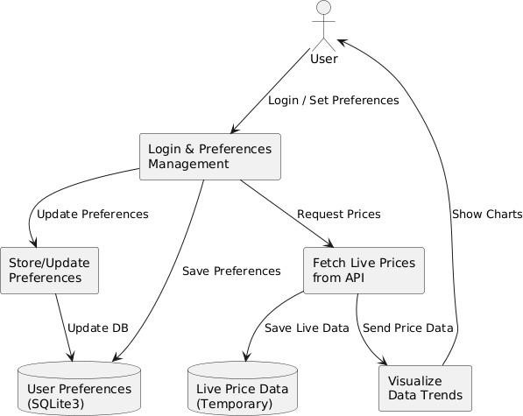

  - Number of Modules and Process Logic (Module Chart)
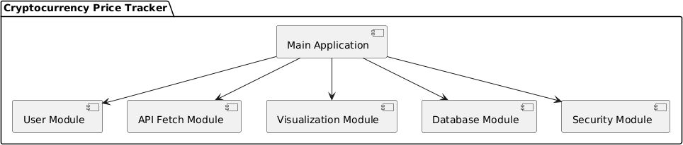

  - Data Structure and Tables
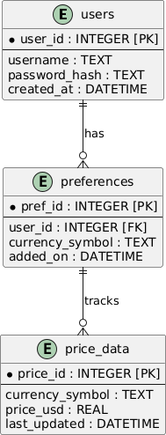

  - System Chart / Structure Chart
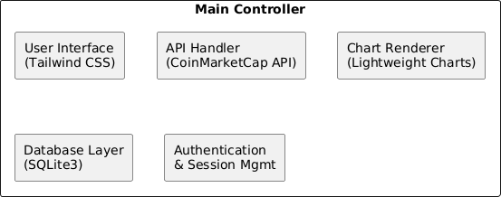

  - Entity Relationship Diagram (ERD)
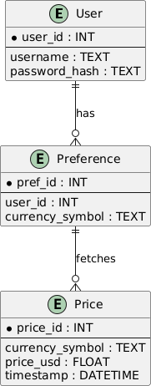

CHAPTER NO.6
System Design

- System Design

Form Design
Form design is critical for collecting user input efficiently and accurately. The application uses minimal but effective forms to ensure a clutter-free user interface while achieving necessary functionality.

Main Forms in the System:
    - User Login Form
      - Fields: Username, Password
      - Function: Authenticates users to access personalized tracking preferences.

User Registration Form
      - Fields: Username, Password, Confirm Password
      - Function: Allows new users to create an account with encrypted credentials.

Preferences Form
      - Fields: Cryptocurrency symbols (selectable), Update interval (in minutes)
      - Function: Stores user-specific preferences for price tracking.

API Configuration (Admin use)
      - Fields: API Key input
      - Function: Enables administrators to set or update the API key used for fetching live data.
Form validation is implemented both on the client side (JavaScript) and server side (Flask) to ensure proper data entry and prevent malicious input.

Input Screens
Input screens provide users with an interface to interact with the application and feed data. Designed using Tailwind CSS, these screens are responsive and optimized for both desktop and mobile devices.

Key Input Screens:
    - Login Screen
      - Simple and clean interface for authentication.
      - Includes options like “Forgot Password” and “Sign Up”.

Registration Screen
      - Ensures strong password policies and confirms matching passwords.
      - Guides users step-by-step.

Preferences Selection Screen
      - Allows users to choose which cryptocurrencies to track.
      - Dropdowns and multi-select checkboxes are used for a smooth experience.
      - Users can also set the refresh interval.

Settings Page
      - Optional: Users can update password, reset preferences, or enable/disable dark mode.

6.3 Form Design

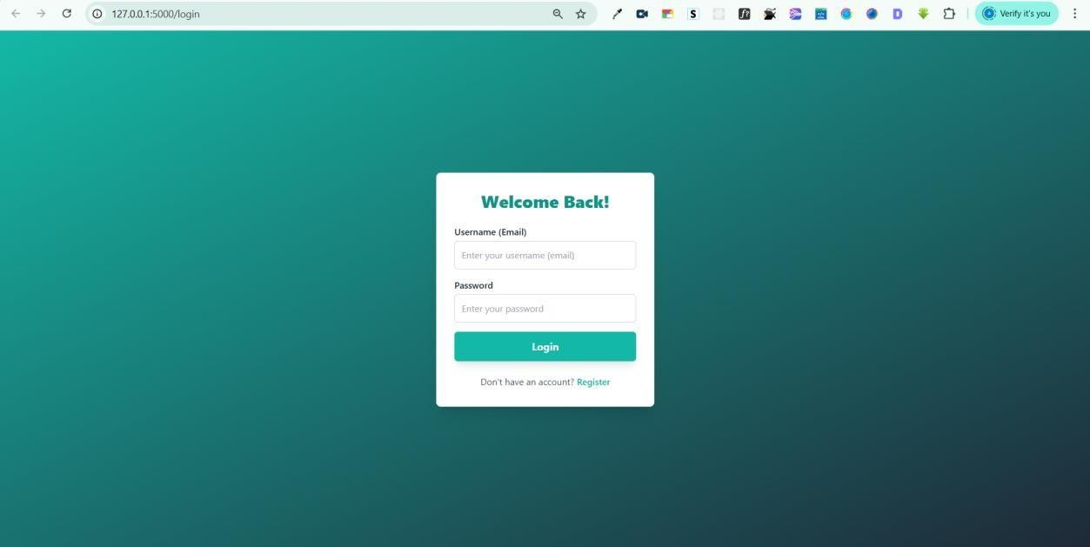

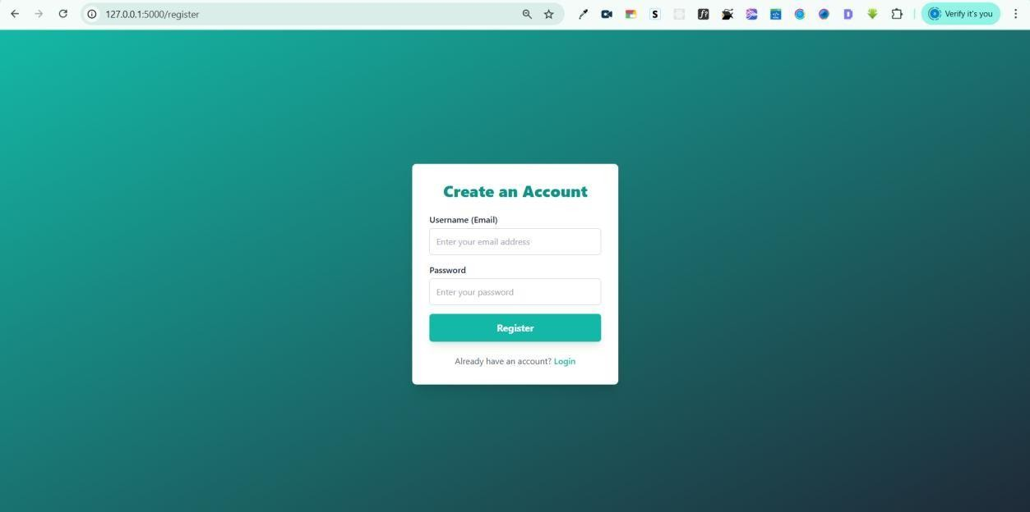

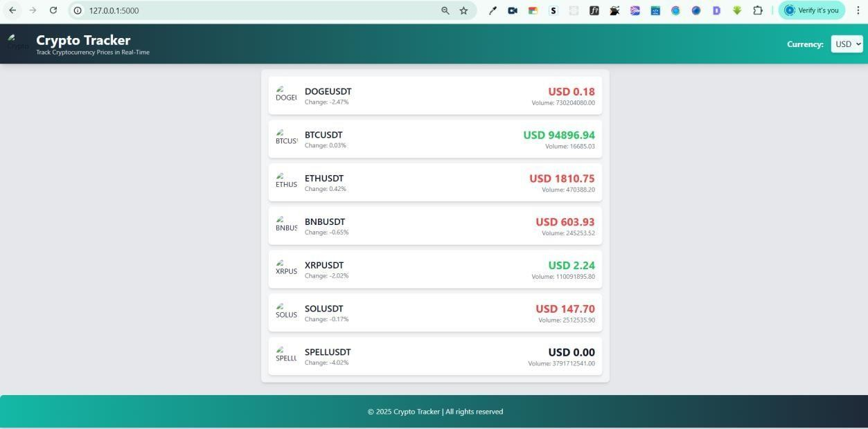

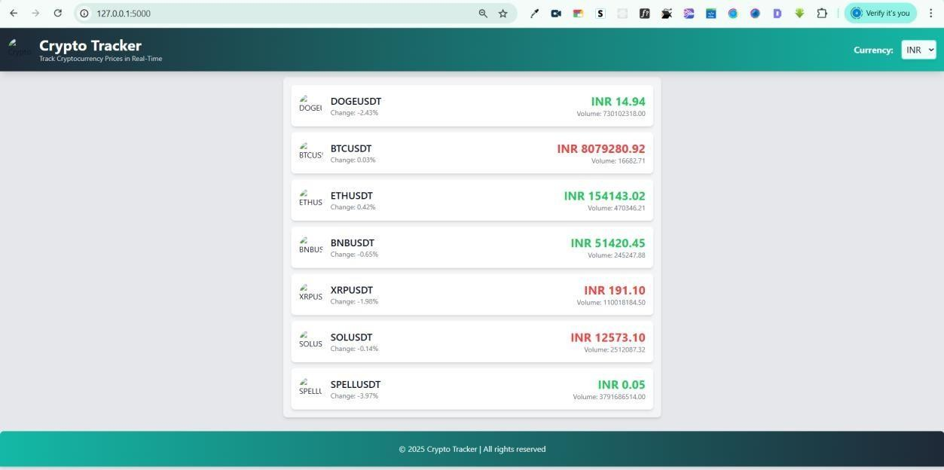

6.4Output Screen

Output screens are the core of the application, providing real-time insights, trends, and visual feedback based on user preferences.

Key Output Screens:

    - Dashboard Screen

      - Displays a list of selected cryptocurrencies along with:

        - Live price

        - 24-hour change

        - Market cap

        - Volume

      - Automatically refreshes every few minutes based on user settings.

Chart Visualization Screen

      - Renders Lightweight Charts for each cryptocurrency.

      - Interactive features like zoom, pan, and time-range selection.

      - Allows users to switch between line, candlestick, or area chart formats.

Notification or Alert Section

      - Optional: Displays price alerts or news related to selected.

CHAPTER NO.7

Testing And Validation

Testing And Validation

Testing and Validation Checks

Testing is a critical phase in the software development lifecycle that ensures the application meets its intended requirements and functions correctly in all scenarios. For the Cryptocurrency Price Tracker, a structured testing methodology was adopted to validate the system's functionality, reliability, and performance.

Unit Testing

Unit testing involves testing individual components or modules of the application in isolation. Each unit was tested separately to identify bugs and ensure logical correctness. For instance, the login functionality, user registration, API call handling, and chart rendering logic were all tested as discrete units. This type of testing helped in quickly identifying specific errors at the code level.

Integration Testing

Integration testing ensures that different modules of the application work together as expected. For the Cryptocurrency Price Tracker, integration testing was performed between the frontend and backend modules. Tests were conducted to verify the successful transmission of user preferences from the frontend to the backend and then fetching and rendering the appropriate data using Lightweight Charts. This helped in validating the correctness of API responses and their proper display.

System Testing

System testing is the process of testing the complete and fully integrated software system. It verified whether the application, as a whole, meets the specified requirements. Real-time data was fetched from the CoinMarketCap API and rendered on the frontend interface. The application's performance under different loads, as well as its compatibility across multiple browsers like Chrome, Firefox, and Edge, was assessed.

User Acceptance Testing (UAT)

UAT was conducted by allowing a group of users to interact with the system and provide feedback. They tested the ease of navigation, the accuracy of the data presented, and the clarity of charts. Suggestions regarding UI improvements and additional features such as dark mode.

Validation Checks

To prevent incorrect or malicious data entry, the following validation checks were incorporated:
- Client-side Validation: Ensures that form fields like username, password, and cryptocurrency symbols are properly filled out before submission.
- Server-side Validation: Adds an extra layer of security by re-validating data on the server to prevent SQL injection and unauthorized API access.
- Cryptocurrency Symbol Validation: Only valid and supported symbols are processed.
- Data Update Validation: Verifies that the fetched data is fresh and aligns with user- set refresh intervals.
The combination of these testing levels and validation checks ensures a robust and error-free system that can reliably track real-time cryptocurrency prices for users.

CHAPTER NO.8

Implemention And Maintenance

Implementation, Evaluation, and Maintenance

Implementation

The implementation phase marks the transition from design and development to a live environment. For the Cryptocurrency Price Tracker, implementation involved deploying the application on a local Apache server, setting up the database, integrating the API, and ensuring compatibility across platforms.
The system was developed using Python (Flask) for the backend, PHP for handling API communication, SQLite3 as a lightweight and file-based database, and Tailwind CSS for the frontend. Each component was carefully configured to ensure seamless interaction between the modules.
Steps taken during implementation:

- Set up virtual environment for Python and installed Flask.

- Configured PHP scripts for API integration.

- Created and initialized the SQLite3 database schema.

- Designed frontend pages using Tailwind CSS.

- Linked Lightweight Charts to dynamically reflect API data.

Evaluation

Post-deployment, the system was evaluated for performance, user experience, and accuracy:

- Performance Evaluation: Measured API response times, chart loading speed, and database query execution.
- Usability Evaluation: Collected user feedback to assess UI friendliness, responsiveness, and ease of navigation.
- Accuracy Evaluation: Verified correctness of real-time data and consistency across sessions.

The system successfully met its performance benchmarks, with API calls taking less than 1 second under typical conditions and charts rendering without lag.

Maintenance

Ongoing maintenance ensures the long-term viability and relevance of the application:

- Bug Fixing: Errors and bugs reported by users are logged in a tracking system and resolved in regular updates.
- API Monitoring: Since third-party APIs like CoinMarketCap can change, the application monitors for changes in endpoint structure or authentication requirements.
- Database Management: Periodic backup scripts are in place to prevent data loss.

- Security Updates: Any new security vulnerabilities discovered are patched immediately.
In conclusion, thorough implementation, careful evaluation, and proactive maintenance have laid a solid foundation for the Cryptocurrency Price Tracker, enabling it to serve its users effectively and efficiently.

CHAPTER NO.9

Reports And Discussions

Reports and Discussions

Throughout the development and deployment of the Cryptocurrency Price Tracker, multiple reports were generated to track progress, identify issues, and inform decisions. These reports played a vital role in understanding system behavior and guiding improvements.

Types of Reports

- Bug and Error Logs: During testing, all encountered bugs were logged, categorized by severity, and resolved systematically. This helped in tracking recurring issues and improving system stability.
- Performance Logs: These logs monitored API response times, load times of charts, and overall page responsiveness. Performance trends were analyzed to identify bottlenecks.
- User Feedback Reports: Feedback was collected through online forms and direct interviews with test users. This provided qualitative insights into usability and user satisfaction.
- Security Reports: Periodic scans for vulnerabilities were performed using automated tools, and any anomalies were documented and resolved.
- Compatibility Reports: Detailed tests on various browsers and devices helped ensure consistent behavior across platforms.

Discussion

The primary goal of the system—to provide real-time, accurate, and user-friendly cryptocurrency tracking—was achieved. Users appreciated the clean UI, fast updates, and responsive design. However, some limitations were observed:
  - API Rate Limits: Free tier API usage was sometimes restricted during heavy testing.

  - Lack of Advanced Features: Some users requested advanced chart indicators and portfolio integration.
  - Mobile Optimization: Although responsive, certain charts could be further optimized for smaller screens.
Despite these minor drawbacks, the system proved to be a practical and efficient tool for crypto enthusiasts and investors. The use of lightweight technologies and minimal server dependencies makes it cost-effective .

CHAPTER NO.10

Future Scope

As the cryptocurrency ecosystem evolves, the Cryptocurrency Price Tracker has numerous opportunities for enhancement and expansion.

Mobile Application Development

Building a native mobile app would provide better accessibility and real-time notifications, significantly improving user experience. Features like biometric login and device-specific preferences could be integrated.

Portfolio Management

Users could be allowed to track and manage their actual investments. This feature could include profit/loss calculators, average purchase prices, and holding history.

Alerts and Notifications

Price alerts, news updates, and market trend notifications could be delivered via email, SMS, or push notifications, ensuring users stay informed on the go.

Multi-Language Support

By supporting multiple languages, the application can cater to a more diverse global audience, increasing its reach and user engagement.

Advanced Analytics and AI Integration

Incorporating artificial intelligence could allow for predictive analytics, helping users anticipate market trends. This could be particularly useful for day traders and analysts.

CHAPTER NO.11

Bibliography

Bibliography

- CoinMarketCap API Documentation – https://coinmarketcap.com/api/
- Flask Documentation – https://flask.palletsprojects.com/
- SQLite3 Documentation – https://www.sqlite.org/docs.html
- Tailwind CSS Documentation – https://tailwindcss.com/docs
- TradingView Lightweight Charts – https://tradingview.github.io/lightweight-charts/
- W3Schools – https://www.w3schools.com/
- Mozilla Developer Network (MDN) – https://developer.mozilla.org/
- Python Official Documentation – https://docs.python.org/
- Stack Overflow – https://stackoverflow.com/
- GitHub – https://github.com/

